**Mansi Uniyal**

**19EE10039**

**PART - A**

**Triggering Circuit:**

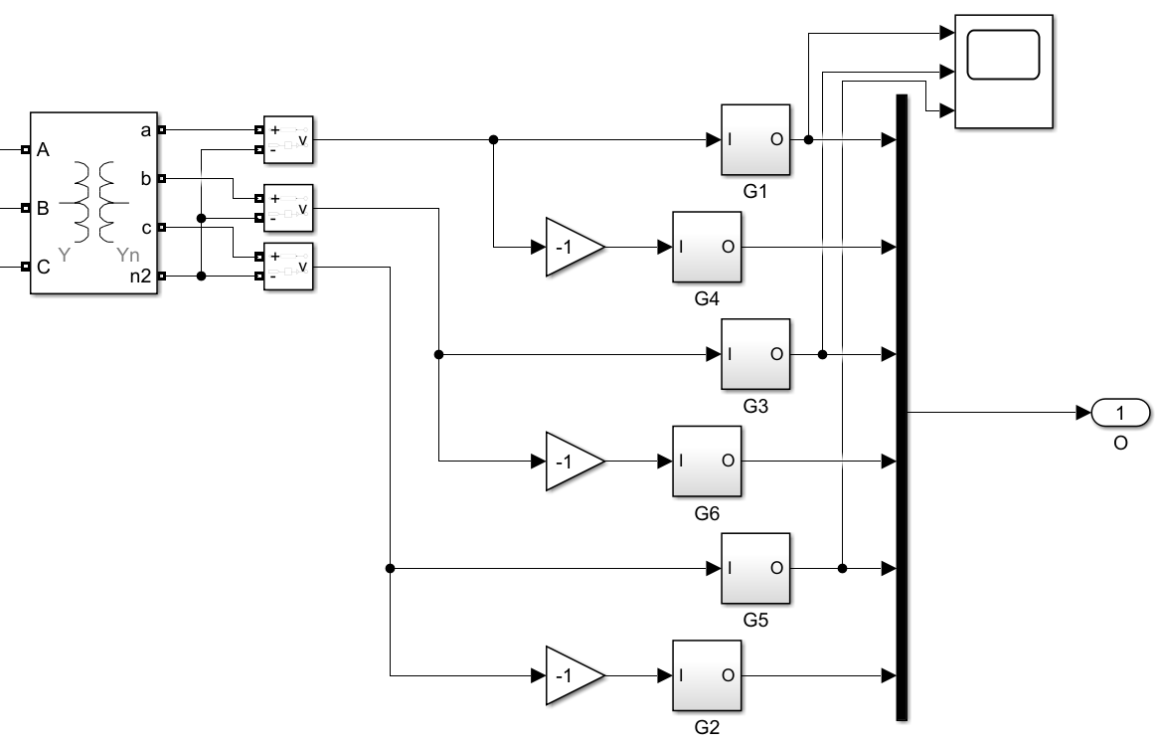

**G1:**

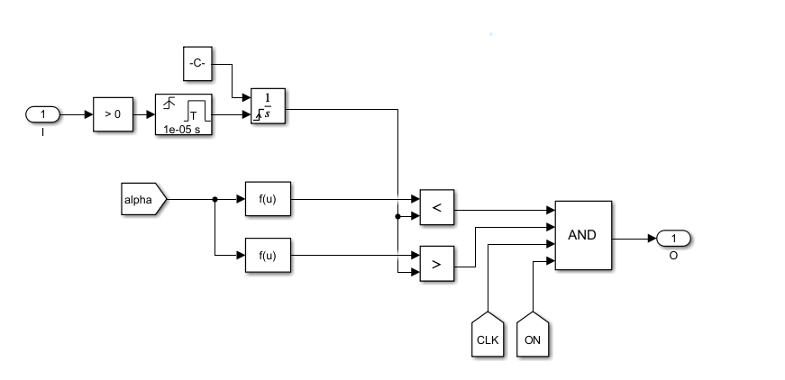

**PART - B**

**Circuit Diagram:**

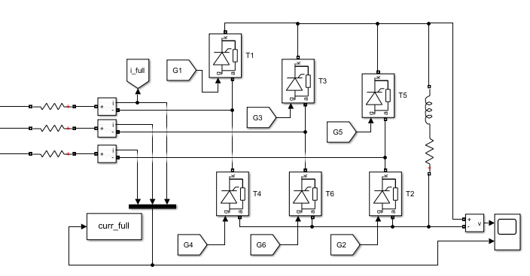

**1.**

Vrect=(3*sqrt*(3)/pi)*Vm*cos(a)

Id.R=(3*sqrt*(3)/pi)*Vm*cos(a)

Id=5A

a=0

Vm=220*sqrt(2/3)

5*R=220*sqrt(2/3)*(3*sqrt*(3)/pi)*cos(0)

R=59.42 ohm

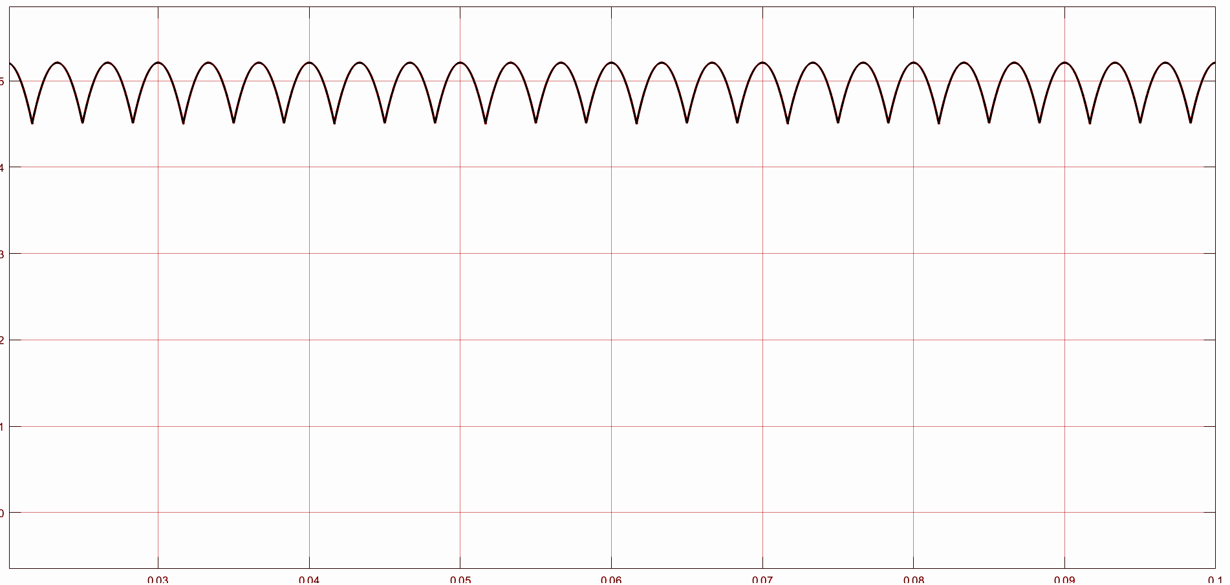Average load current = 4.972 A

**2.**

Vrect=(3*sqrt*(2)/pi)*220*cos(a)=220

cos(a)=pi/3*sqrt(2) = 0.7405

a=42.23 deg

**3.**

Output Voltage:

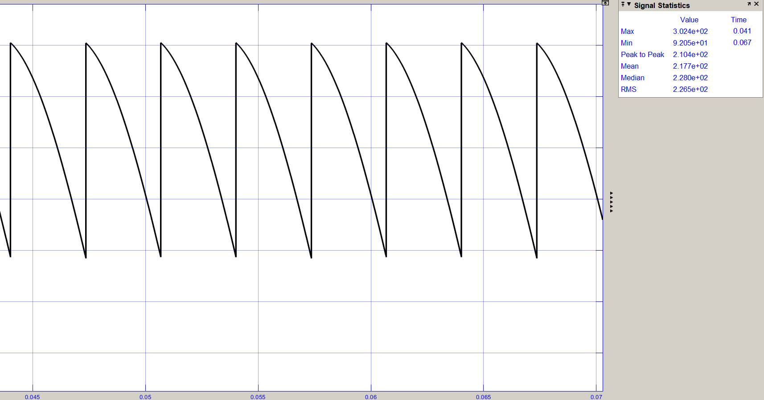Average output voltage = 217.7 V

**AC side currents:**

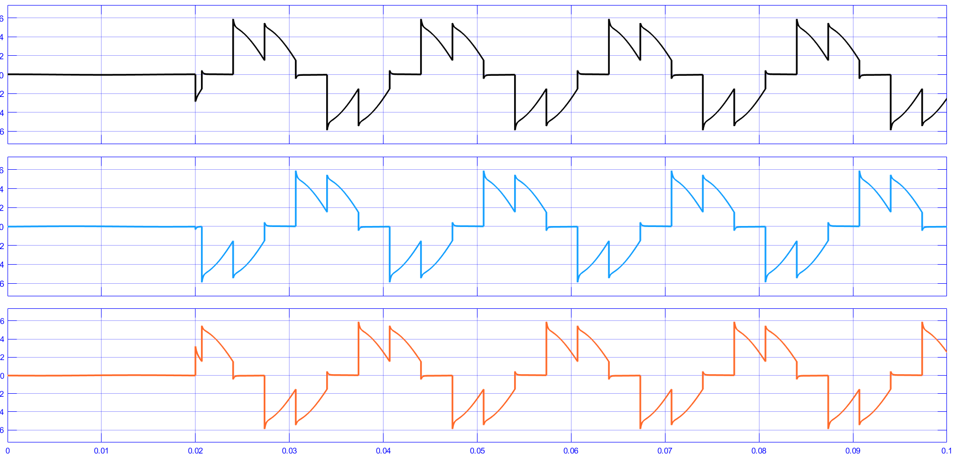

**4.**

R = 59.421 Ω

| **Alpha (degree)** | **Average output Voltage**  **(V)** | **AC side current (RMS)**  **(A)** |
| --- | --- | --- |
| 0 | 295.5 | 4.06 |
| 15 | 284.8 | 3.93 |
| 30 | 255.2 | 3.57 |
| 45 | 208.54 | 3.00 |
| 60 | 146.3 | 2.30 |
| 75 | 87.32 | 1.57 |
| 90 | 39.20 | 0.87 |

**5.**

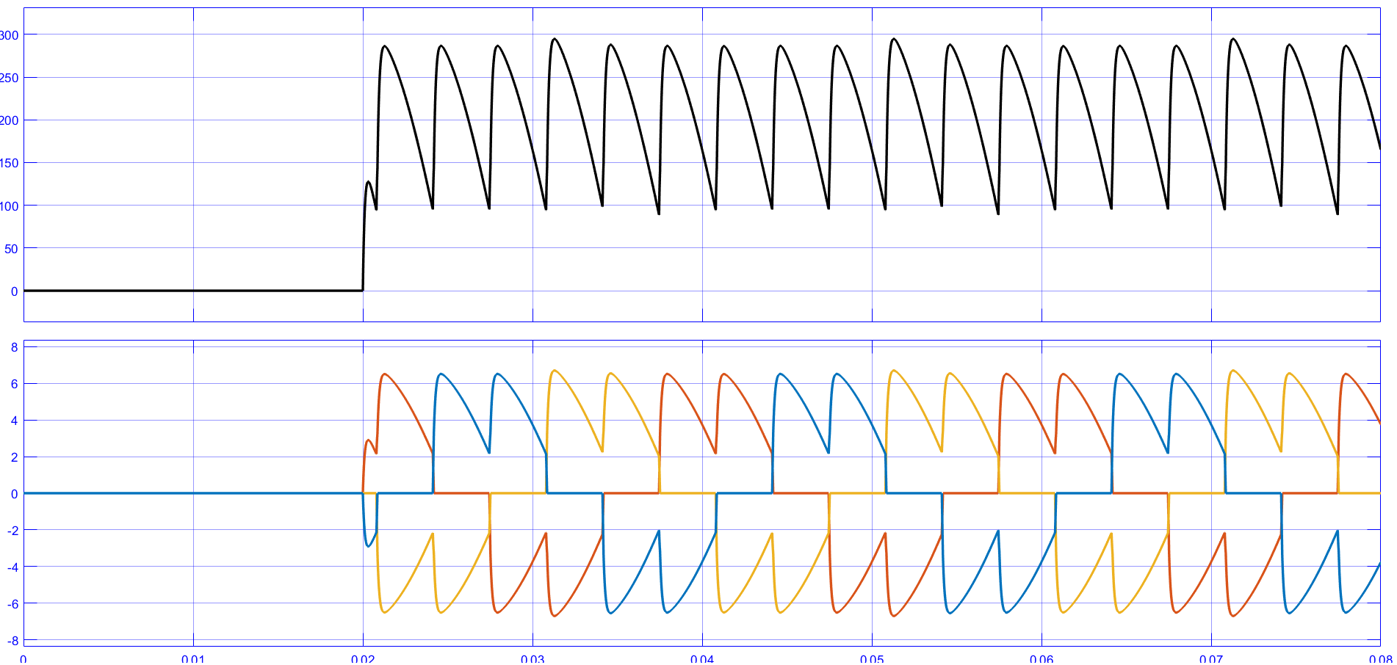

**PART - C**

**Circuit Diagram:**

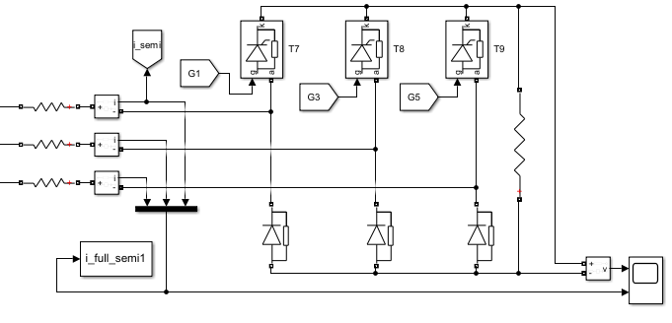

**1.**

Vrect=(3*sqrt(3)/(2*pi))*Vm*(1+cos(a))=Id*R

Id=5A

a=30 deg

Vm=220*sqrt(⅔)

5*R=(3*sqrt(3)/(2*pi))*220*sqrt(⅔)*(1+cos(a))

R=55.44 ohm

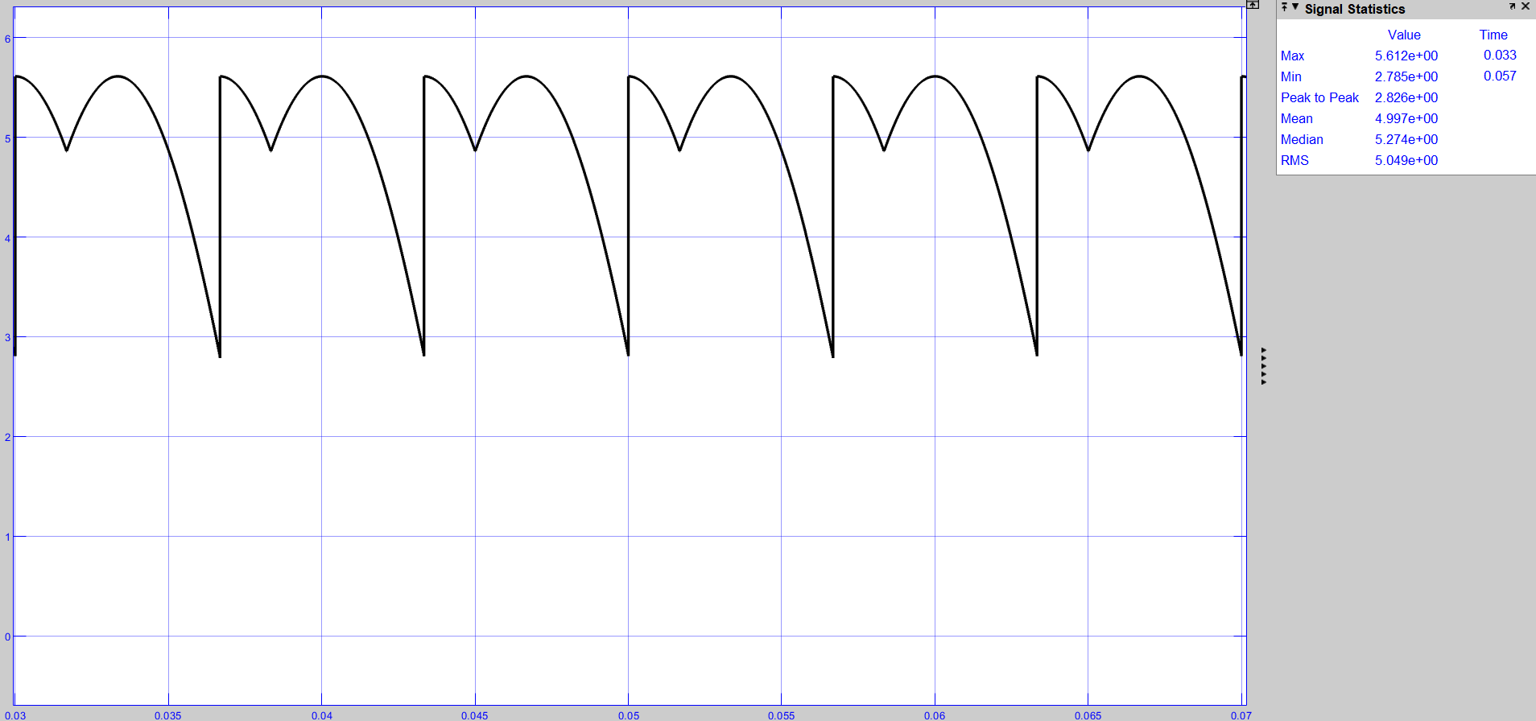Average Load current = 4.997 A

**2.**

Load current at alpha = 59°

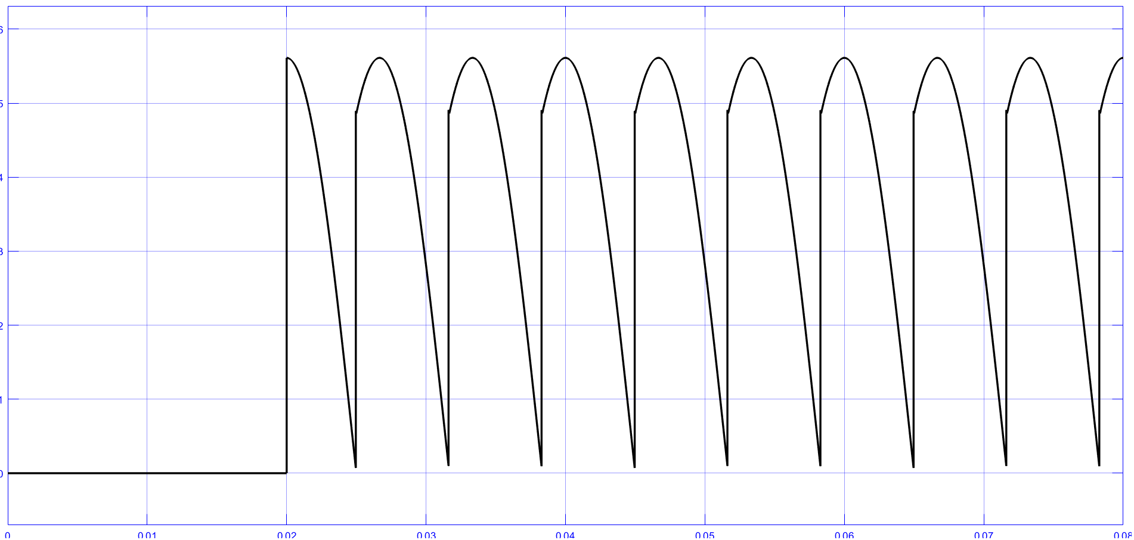

Load current at alpha = 60°

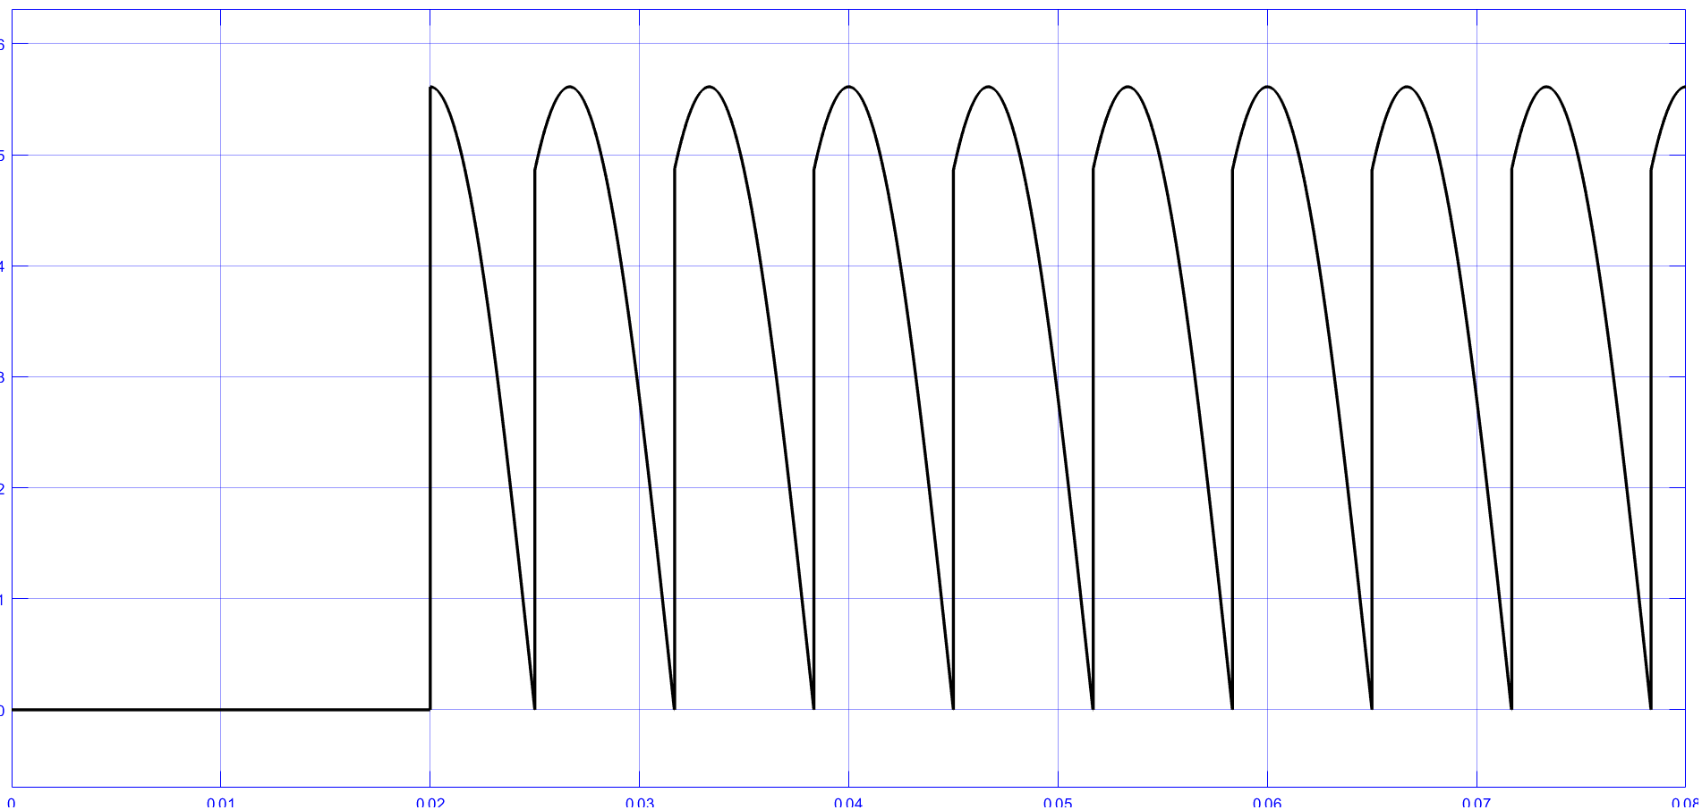

Load current at alpha = 61°

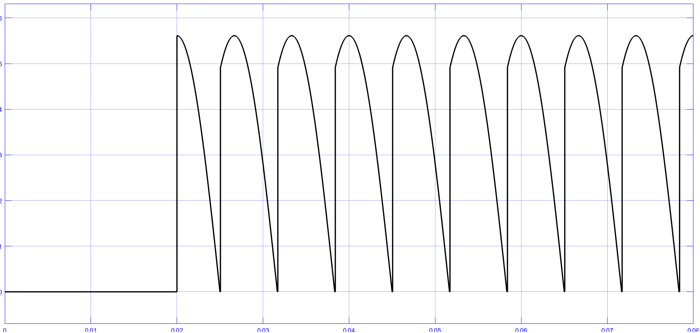

Hence, the load current becomes discontinuous as soon as it crosses alpha = 60°

**3.**

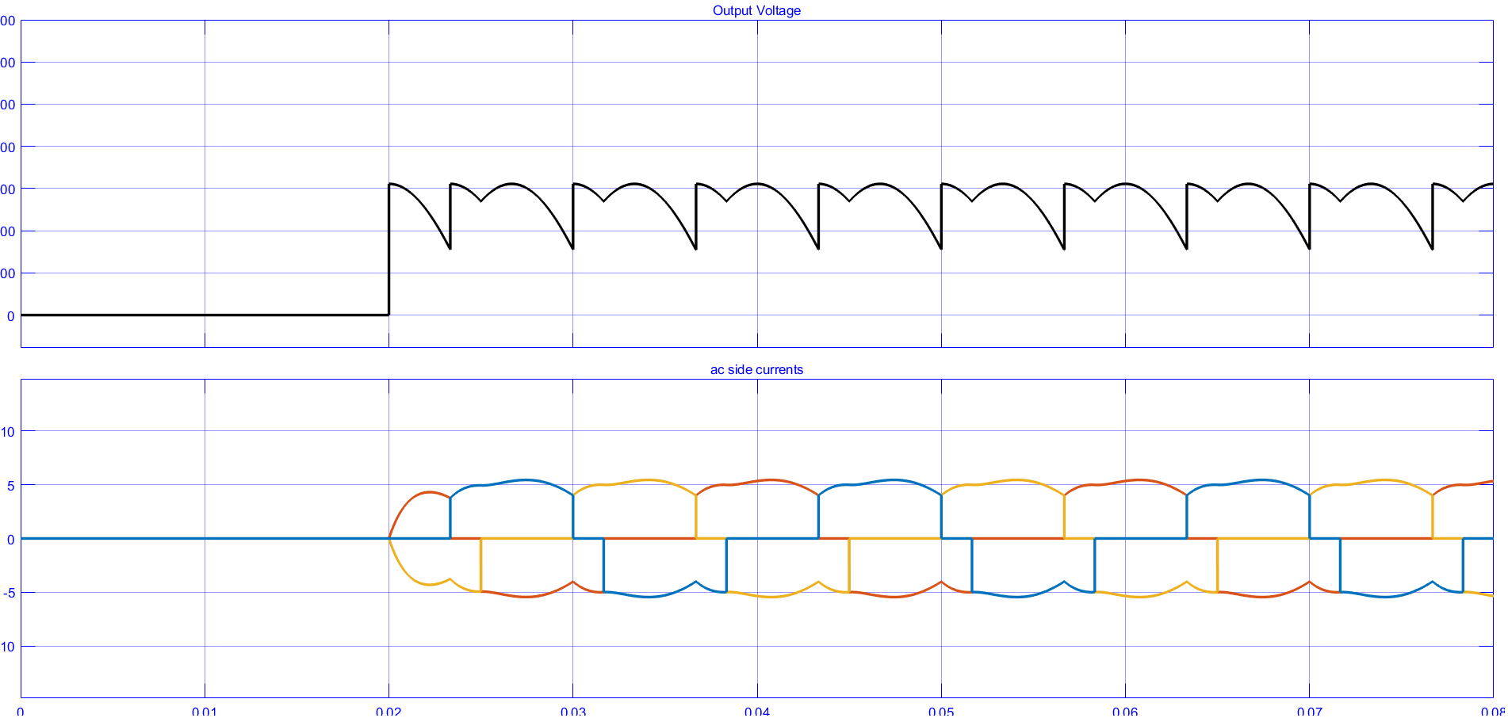Average output voltage = 277.1 V

**4.**

R = 55.44 Ω

| **Alpha (degree)** | **Average output Voltage**  **(V)** | **AC side current (RMS)**  **(A)** |
| --- | --- | --- |
| 0 | 296.8 | 4.31 |
| 15 | 292.1 | 4.23 |
| 30 | 277.3 | 4.01 |
| 45 | 254.3 | 3.68 |
| 60 | 223.1 | 3.28 |
| 75 | 185.2 | 2.86 |
| 90 | 148.0 | 2.42 |

**PART - D**

| Parameter | Full-controlled Converter | Semi-controlled Converter |
| --- | --- | --- |
| AC side currents (RMS) | 4.08 | 4.08 |
| Fundamental component of the AC side currents (RMS) | 3.89 | 3.86 |
| THD (%) of the AC side currents | 31.13 | 34.10 |
| Input power factor | 0.922 | 0.913 |
| Fundamental active power (W) | 2025.60 | 2009.41 |
| Fundamental reactive power (VAr) | 542.7 | 538.4 |

**Discussion Questions:**

1. Consider an ideal three-phase full-controlled converter with an R load. Obtain the expression of the average output voltage (for α ∈ [0, π/2]).

Avg output voltage of ideal 3 phase fully controlled converter with R load:

(i) a in [0,pi/3]

Vrect=(3/pi)*integral(sqrt(3)*Vm*sin(wt+(pi/6))) ...from limit a+pi/6 to a+pi/2

=3sqrt(3)*Vm*cos(a)/pi

(ii) a in [pi/6,pi/2]

Vrect=(3/pi)*integral(sqrt(3)*Vm*sin(wt+(pi/6))) ...from limit a+pi/6 to pi

=3sqrt(3)Vmcos(a+pi/3)/pi

2. Refer to Part B(5), what is the commutation overlap angle µ? What is the average output DC voltage?

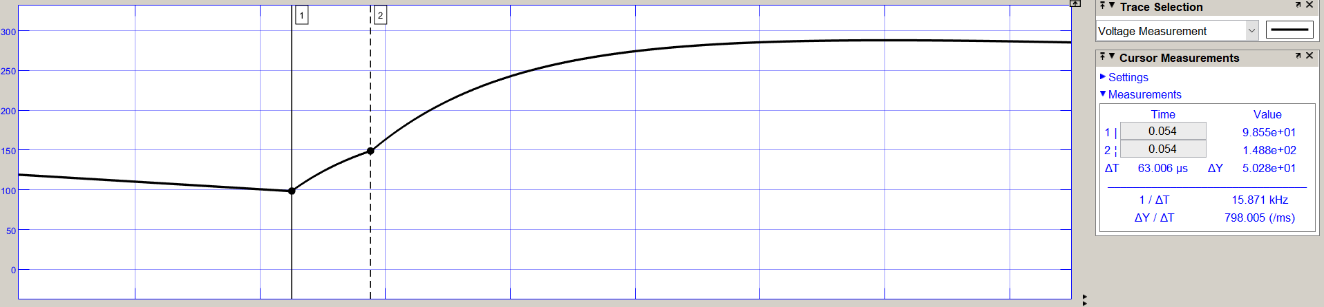ΔT = 63.006 μs

Commutation overlap angle = (63.01* 10^-3 / 3.33) x 180 deg= 3.41 deg

Average DC voltage = 212.1 V

3. Refer to Part D, compare the distortion factor of the two converters. Why is the distortion factor less in the case of the semi-controlled rectifier?

Distortion factor of three-phase fully controlled AC to DC converter = I1/I = (3/pi) = 0.955

Distortion factor of three-phase semi-controlled AC to DC converter = I1/I = √(6/pi(pi-a)) x cos(a/2)= 0.807 for a = π/12.

For a semi-controlled rectifier, the diodes allow more harmonics in the output. That is why the distortion factor is less for semi-controlled AC to DC converter.